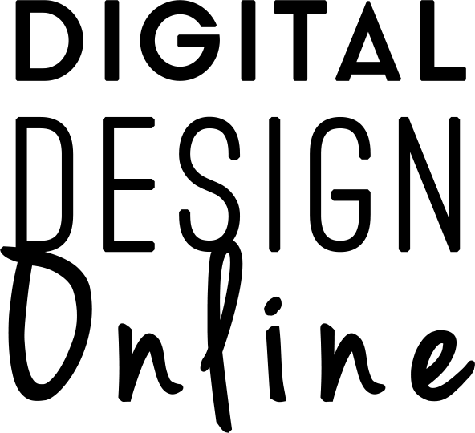

LOGO DESIGN PROJECT FORM

Thanks for Choosing Digital Design Online for Your Project!
We Can’t Wait to Get Started!

Please fill in this project content form so that we have all of the necessary information to capture your project vision and requirements.

- YOUR CONTACT DETAILS

Full Name:

Contact Number:

Business Name:

Email Address:

Existing Website Address (If applicable):

Exiting Logo Copied Here (if applicable)

- GENERAL BUSINESS INFORMATION

2.1 What is your industry?
Please write a short description.

2.2 What services do you provide?
Please write a short description.

2.3 Who is your target market?
Please write a short description. (Any information such as, location, gender, age, industry specifics)

2.4 If you are not a new business startup – What is your reason for wanting a new logo?

- NAME BRANDING

3.1 Company Name
What is your company name? Please write the exact name, as you would like to appear in your logo.

3.2 Strapline
What is your tagline if applicable? Do you want this in the logo?

- LOGO DESIGN

4.1 Logo Examples
Please copy and paste some examples of logos you like the look of putting a note next to the one you like best and why. (You can copy and paste image links or send images directly to hello@digitaldesignonline.co.uk).

4.2 Do you have a specific idea in mind for your logo?
Please explain below.

4.3 Styling
Please supply a brief description of the design you have in mind and any other information that would be useful. This can include information such as, colours, style, do you want an image icon with it, or just typography, etc.

4.4 Sizing
Do you require any specific sizing for the logo? Please specify or leave blank.

4.5 Images & Icons
Do you have specific images or icons that you wish or do not wish to be in your logo?

4.6 Colours You Want?
Do you want to use a particular colour? Please List below with colour codes or a copy and paste example.

4.7 Colours You DON’T Want?
Are there any colours that you do not want to use?

4.8 Do you have a particular font or font style you would like us to use? Or ones you definitely do not want to use?

Thanks Again for Choosing Digital Design Online for Your Project!

As soon as we receive your form we will get started on your project and will advise you if we require any further information. You can contact us with the email address below should you need to.

HELLO@DIGITALDESIGNONLINE.CO.UK
www.digitaldesignonline.co.uk

